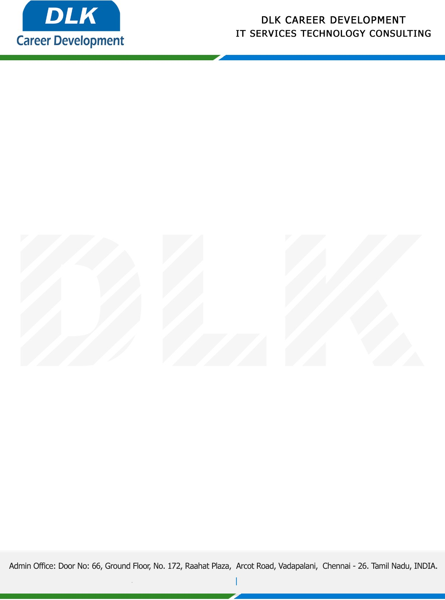

Date: 10/ December / 2022

**To**

Department of BE ([Electronics and Communication),](https://www.cseindia.org/)

Head of Department,

Velammal Engineering College, Chennai - 600066.

**Sub: Letter of Internship Acceptance**

This is to certify that **MS DHEBIKA C (REG NO: 113220041033)** that third year student of has accepted her Internship Work duration from **13th December 2022** to **27th December 2022** under the domain ”**EMBEDDED SYSTEMS”.** During the internship, all information and data collected from your should be kept confidential.

We appreciate your interest in **DLK CAREER DEVELOPMENT**

